**MW Bevel Tool**

# Problem 1.

Bevel an object with the bevel tool. If you switch the selection type from edge to object, you can’t select it by clicking it.

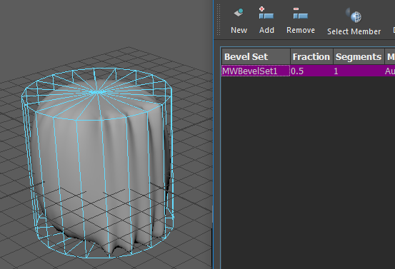

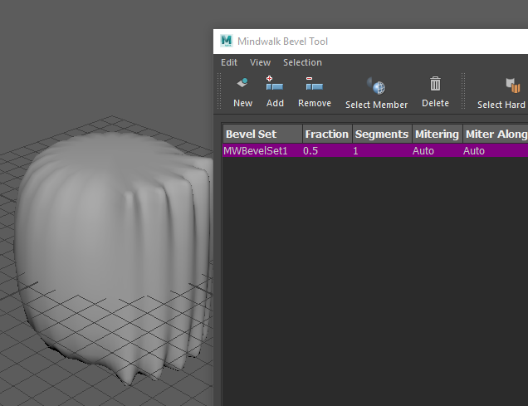

## Cause

Switching the selection type doesn’t change the active selection list. So *selectionChanged**MEventMessage*isn’t triggeredand Maya doesn’t run

its callback ***_****selectionChangedCallback*.

## Version

2017

# Problem 2

Switch the selection type directly by clicking right button, rather than click it first. This doesn’t triggered *selectionChanged**MEventMessage.*